**PROJECT TITLE: Development of a Remote-Controlled Robot for Hazardous Gas Detection with MQ2 Sensor**

**Submitted by: Alvin Jay Maique  
 Lindon Matarong  
 Rhea Paraiso**

**Project Goals and Objectives:**

**• To ensure the robot accurately identifies specific harmful gases in real time**

**• To allow users to control the robot and receive alerts from a safe distance**

**• To develop an intuitive control system for easy navigation and monitoring**

**• To implement immediate alerts for detected gas levels to ensure prompt action**

**Brief Background:**

# Smart Fault Detector Robo to Detect Gas and Fire: The Smart Fault Detector Robo improves safety standards by employing modern sensors, AI, and robots for the early detection of gas leaks and fire events, capable of recognizing hazardous gasses like methane and carbon monoxide with high precision and real-time data processing. However, it has drawbacks such as sensor performance being influenced by ambient conditions, the possibility of false positives/negatives, and dependency on a constant power source. To solve these challenges, the report proposes increased sensor calibration, continual improvements to AI algorithms, and the introduction of backup power systems to assure operational reliability during outages.

<https://www.ijraset.com/research-paper/smart-fault-detector-robo-to-detect-gas-and-fire>

# Semi-autonomous Gas Detecting Robot (Hazmat Robot): The study introduces a semi-autonomous gas-detecting robot aimed at improving safety in environments with gas leak risks. It autonomously explores areas, reporting gas readings via a wireless interface to identify hazardous "hotspots." The robot employs various sensors and is powered by a Raspberry Pi, programmed in Python, allowing it to navigate around obstacles effectively. While the study does not explicitly outline limitations, common challenges may include sensor reliability in diverse conditions and navigation in complex terrains. The solution involves integrating multiple sensors and a robust programming framework to enhance operational capabilities in hazardous environments.

https://link.springer.com/chapter/10.1007/978-3-031-47448-4_14

**Gas leak source detection robot using finite state machine model (fsm):** The study presents a gas detection simulation robot designed using a Finite State Machine (FSM) model to identify gas leaks, particularly in industrial areas where toxic gases pose significant risks. The robot successfully detected gas leaks in various scenarios, achieving an accuracy of 92.5% after 40 tests across four different arenas. However, the study acknowledges limitations, such as the robot's inability to operate effectively in extremely tight spaces or hazardous environments where human presence is required. To address these limitations, the authors propose further development of the robot to enhance its capabilities as a gas leak detection inspection tool, aiming to create an early warning system for gas leaks.

<https://ejournal.kresnamediapublisher.com/index.php/jri/article/view/66>

# Safety Robot for Flammable Gas and Fire Detection using Multisensor Technology: The study introduces a safety robot that detects flammable gases and fire in industrial environments using MQ2 and MQ8 gas sensors. It autonomously follows a line to monitor gas pipelines, alerting workers with a buzzer and sending notifications via an ESP8266 Wi-Fi module. The robot also features a flame sensor on a servo motor to detect fire directionally, providing alerts and GPS location to the firefighting department in emergencies. While the study does not specify limitations, a potential issue could be the robot's dependence on specific sensors, which may not detect all hazardous gases or fires. The solution involves integrating multiple sensors and a communication system to enhance safety responses in the workplace.

<https://ieeexplore.ieee.org/document/9591676>

**A Mobile Robot for Hazardous Gas Sensing:** This study details the development of a mobile robot for detecting hazardous gases, capable of mapping their GPS locations and transmitting data to a remote device, aiding disaster management. The robot features gas sensors, human detection sensors, GPS, and obstacle detection systems, allowing it to navigate and avoid collisions while achieving a 98% accuracy in gas identification through a neural network-based classifier. While specific limitations are not mentioned, potential issues could include sensor accuracy and environmental factors affecting performance. The solution employed is the neural network-based classifier, which enhances the reliability of gas detection in real-time.

<https://ieeexplore.ieee.org/document/9200082>

# Gas Ascertainment via Smartphone (GAS): is an innovative gas detection solution that combines a smartphone application with a small robot. Designed for affordability and user-friendliness, the system operates on Android and connects to a single-board computer in the robot. Users can control the robot's movements via touch buttons on their smartphone, receiving real-time alerts when gas sensors detect dangerous levels. This setup allows safe operation from a distance, making factories and storage areas safer. Future enhancements may include data transmission over the Internet, compatibility with other mobile operating systems, and advanced features like following gas leak sources.

# <https://www.researchgate.net/publication/257411038_Gas_Ascertainment_via_Smartphone>

# 

# Development of a Patrol Robot for Home Security with Network Assisted Interactions: The paper details the development of a patrol robot system designed for home security, emphasizing its interactive capabilities. The robot incorporates various sensors to monitor the environment and detect events such as fire alarms, intruders, and gas leaks. To enhance human-robot interaction, features like a face mask displaying different facial expressions and a force feedback steering wheel controller are included. Sensor data and interaction functionalities can be accessed remotely via the Internet. The system also features an indoor patrol algorithm that enables the robot to navigate autonomously, avoiding obstacles and following wall baselines using a combination of ultrasonic and vision data. The patrol robot was tested in the second floor of the EE building on campus, demonstrating its effectiveness through experimental results.

# <https://doi.org/10.1109/SICE.2007.4421116>

# 

# Designing a wheeled robot model for flammable gas leakage tracking: A wheeled robot model for tracking flammable gas leaks along pipelines offers a safer alternative to manual inspections. Traditional methods expose workers to risks of fire and hazardous environments. This intelligent model is built on an Arduino microprocessor and features an MQ2 gas sensor, LED indicators, and a buzzer alarm for alerts. It uses a line-following principle to navigate the pipeline, effectively sensing gas presence and stopping approximately 5.87 cm from the leak. Additionally, it records data in a DATA.txt file on a microSD card for future analysis, demonstrating its performance and reliability in leak detection.

# <https://doi.org/10.1109/IAC.2017.8280657>

# 

# Mobile Robot Tracker for the Presence of Gas in a House Prototype Using Left Hand Rule Based on PID: A mobile robot prototype designed to detect gas in residential settings operates autonomously using a left-hand rule navigation method. Built on an Arduino Uno microcontroller with C programming, it features two ultrasonic sensors and an MQ-6 gas sensor. The robot starts from a predetermined point, following walls and detecting gas at specified locations. Testing results indicate effective navigation and gas detection capabilities, with the MQ-6 sensor identifying gas concentrations of 800 PPM. The implementation of PID values (kp=40, ki=0.0001, kd=2) enhances its performance, positioning the robot as a valuable tool for assisting in gas leak detection.

# <https://doi.org/10.1109/ICMERALDA60125.2023.10458157>

# 

# A UAV system designed for autonomous target detection and gas sensing: offers an effective solution for monitoring environmental gases in large, remote areas. Equipped with an onboard camera and a carbon dioxide gas sensor, the UAV autonomously navigates using a waypoint system while detecting predefined targets indoors. Upon identifying a target, it hovers for 10 seconds to collect Air Quality (AQ) samples. Test results confirm the UAV's ability to detect targets and analyze air quality during flight, with data transmitted in real-time to a Ground Control Station (GCS) for visualization and 3D mapping of gas concentrations. The system’s integration and functionality are validated through various tests. While the image processing algorithm relies on frame transmission rates, potentially slowing down performance, the UAV is positioned for diverse applications, including gas leak detection, fire monitoring, and environmental studies. Its adaptability for outdoor use further expands its potential in areas like agriculture and chemical detection.

# <https://doi.org/10.1109/AERO.2017.7943675>

# Development and Hardware Implementation of IoT-Based Patrol Robot for Remote Gas Leak Inspection : focuses on developing an Internet of Things Robot (IoTR) for gas leak detection and patrolling in various environments. This robot integrates robotic systems with IoT technology, enabling the connection of sensors and smart devices. Its primary function is to detect gas leaks, making it essential for safety in both indoor and outdoor settings. Key features include microphones, speakers, a high-resolution IP video camera for live streaming, Bluetooth for indoor tracking, and GPS/GPRS for outdoor navigation.The robot employs intelligent gas sensors that are cost-effective, highly sensitive, and responsive within 10 seconds. It can be controlled remotely via a mobile app or website and operates autonomously while avoiding obstacles. The project emphasizes affordability by using readily available components, ensuring the robot remains low-cost without sacrificing quality. Preliminary testing has confirmed its effectiveness in detecting gas leaks and providing live video feeds that can be tracked on Google Maps. Overall, this project presents a promising solution for enhancing safety through an innovative IoT-based patrol robot.

https://www.doi.org/10.32985/ijeces.13.4.4

# 

# Toxic gas detection robot: The robot is equipped with an infrared control remote control module, an LCD display module, and a mobile terminal for monitoring. The software is designed using Keil, employing a modular and top-down approach for signal measurement and monitoring. A key feature of the robot is the MQ-7 carbon monoxide sensor, which detects abnormal levels of carbon monoxide. When such a signal is detected, the system processes the signal through an AD converter (AD0832) and transmits it to the microcontroller unit (MCU). The concentration of carbon monoxide is then displayed on the LCD, and if it exceeds a predefined limit, an alarm is triggered. Additionally, the data is sent to a mobile monitor via the HC-05 Bluetooth module, allowing for real-time monitoring and alerts.

<https://www.doi.org/10.1109/IAEAC54830.2022.9930073>

# Domestic Robot for LPG and AC Gas Leakage Detection: A domestic robot designed for early detection of LPG and AC gas leaks, primarily aimed at preventing accidents in kitchens and bedrooms. The robot can detect gas leaks within a range of 25 to 30 feet and raises an alarm if a leak is detected. If the alarm is not turned off within five minutes, it sends SMS alerts to a registered mobile number every 15 minutes until deactivated. The authors emphasize the robot's potential to save lives by addressing the dangers associated with gas leaks, particularly in India, where LPG is widely used for cooking. The robot operates effectively under normal conditions but may malfunction in high smoke environments. It is built using solid-state sensors and a microcontroller, making it both affordable and user-friendly, with future modifications planned to enhance its capabilities.

https://www.doi.org/10.5120/IJCA2019919090

# 

# Indoor dangerous gas environment detected by mobile robot: The paper discusses the development of an intelligent mobile robot designed to detect hazardous or flammable gases in indoor environments, which can pose significant risks if unnoticed. It highlights the limitations of traditional gas source detection methods and introduces a robot equipped with gas sensors, a laser finder, and vision capabilities. Two searching strategies are proposed: one utilizes prior knowledge of the environment to prioritize potential gas source locations, while the other mimics human search behavior by evaluating risk areas through a fuzzy inference system. The robot's efficiency in locating gas sources is enhanced by considering factors such as air flow and odor diffusion, with simulations demonstrating the effectiveness of these strategies in improving search speed and accuracy. <https://www.doi.org/10.1109/ROBIO.2009.5420679>

# Mobile robots with active IR-optical sensing for remote gas detection and source localization: The paper proposes a novel approach for gas leak detection and source localization using mobile robots equipped with active infrared (IR) optical sensors, which allow for remote sensing rather than in-situ measurements. This method enhances safety and efficiency by enabling rapid scans and the ability to detect leaks from a distance, particularly in hard-to-reach areas. The authors present tailored strategies for leak detection and localization, supported by a simulation environment that models gas concentration fields. The effectiveness of the proposed system is demonstrated through a case study in a chemical plant, highlighting the advantages of remote sensing over traditional in-situ gas sensors, which require the robot to enter hazardous areas for detection.

https://www.doi.org/10.1109/ROBOT.2009.5152338

**Project Overview:**

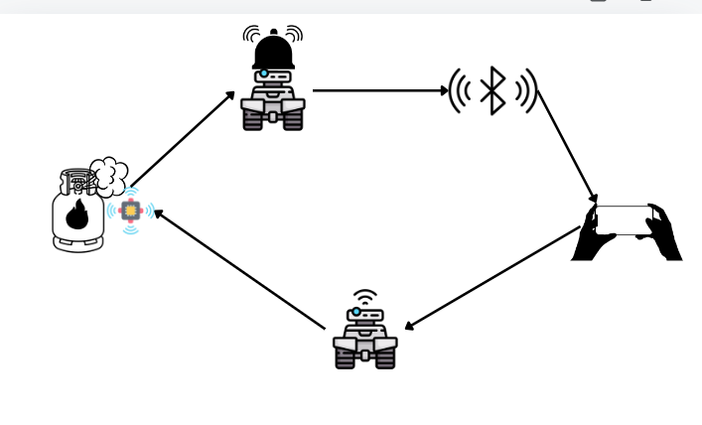

**Figure 1. Project Overview**

***Figure 1 provides an overview of the proposed system. The user controls a robot equipped to detect hazardous gases. Upon detection of such gases, the robot triggers an alarm and sends a signal to the user via a Bluetooth connection.***

**Flowchart:**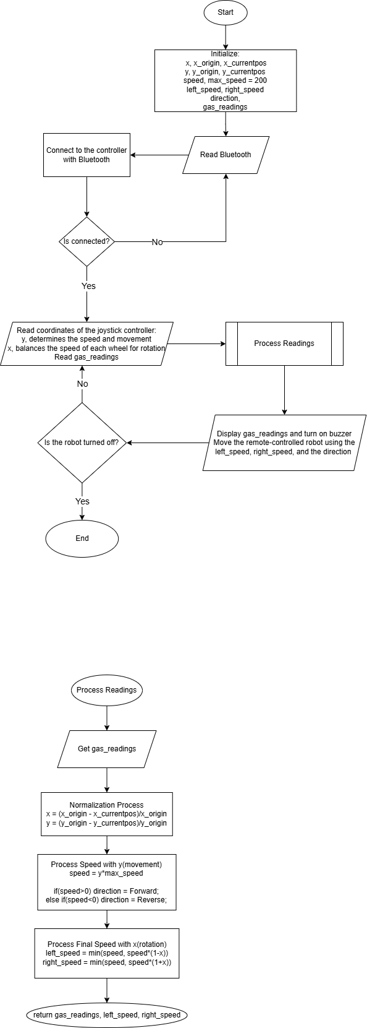

**Process Readings (Subroutine)**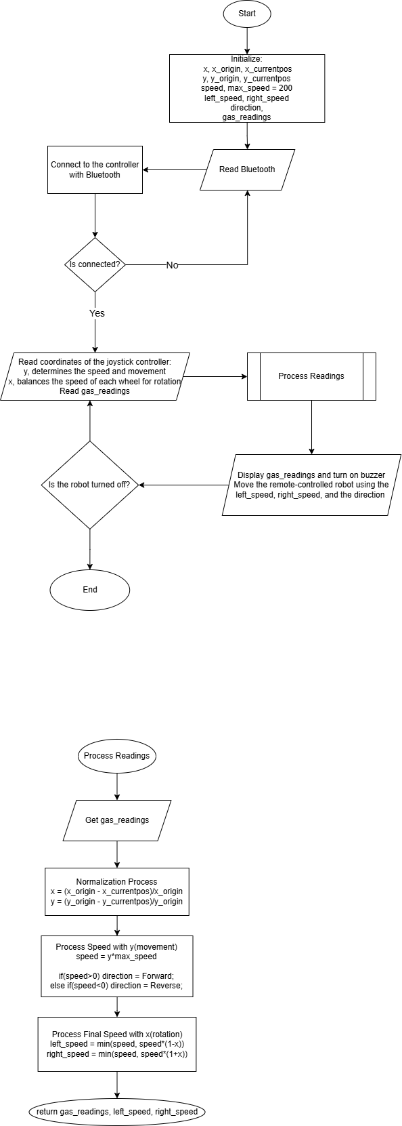

**References:**

# Smart Fault Detector Robo to Detect Gas and Fire:

<https://www.ijraset.com/research-paper/smart-fault-detector-robo-to-detect-gas-and-fire>

# Safety Robot for Flammable Gas and Fire Detection using Multisensor Technology:

<https://ieeexplore.ieee.org/document/9591676>

**Gas leak source detection robot using finite state machine model (fsm):**

<https://ejournal.kresnamediapublisher.com/index.php/jri/article/view/66>

# Semi-autonomous Gas Detecting Robot (Hazmat Robot)

https://link.springer.com/chapter/10.1007/978-3-031-47448-4_14

**A Mobile Robot for Hazardous Gas Sensing**

https://ieeexplore.ieee.org/document/9200082

**Gas ascertainment via smartphone:**

[(PDF) Gas Ascertainment via Smartphone (researchgate.net)](https://www.researchgate.net/publication/257411038_Gas_Ascertainment_via_Smartphone)

**Development of a Patrol Robot for Home Security with Network Assisted Interactions:**

<https://doi.org/10.1109/SICE.2007.4421116>

**Designing a wheeled robot model for flammable gas leakage tracking:**

<https://doi.org/10.1109/IAC.2017.8280657>

**Mobile Robot Tracker for the Presence of Gas in a House Prototype Using Left Hand Rule Based on PID:**

<https://doi.org/10.1109/ICMERALDA60125.2023.10458157>

**A UAV system for autonomous target detection and gas sensing:**

<https://doi.org/10.1109/AERO.2017.7943675>

# Mobile robots with active IR-optical sensing for remote gas detection and source localization:

<https://www.doi.org/10.1109/ROBOT.2009.5152338>

# Indoor dangerous gas environment detected by mobile robot:

# <https://www.doi.org/10.1109/ROBIO.2009.5420679>

# Domestic Robot for LPG and AC Gas Leakage Detection:

<https://www.doi.org/10.5120/IJCA2019919090>

# Toxic gas detection robot:

<https://www.doi.org/10.1109/IAEAC54830.2022.9930073>

# Development and Hardware Implementation of IoT-Based Patrol Robot for Remote Gas Leak Inspection

https://www.doi.org/10.32985/ijeces.13.4.4